Data set Information
Data Set 1
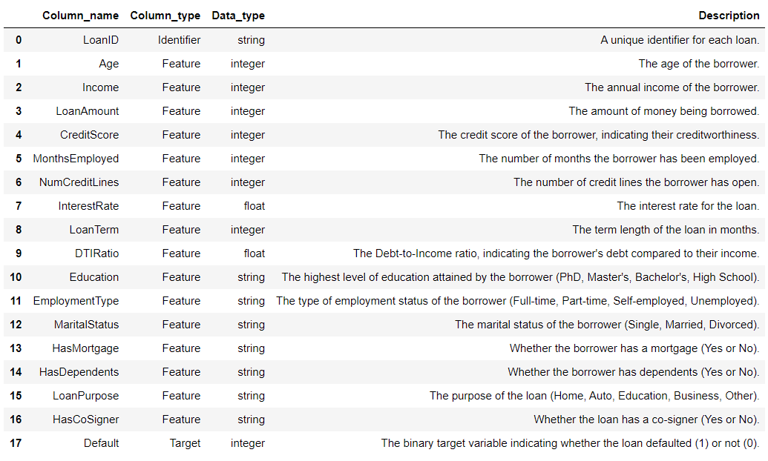
Data Set 2

Metric | Value
Total Records | 50,000
Features | 20 (customer_id + 18 predictors + 1 target)
Target Distribution | 55% Approved, 45% Rejected
Missing Values | 0 (Complete dataset)
Product Types | Credit Card, Personal Loan, Line of Credit
Market | United States & Canada
Use Case | Binary Classification (Approved/Rejected)

Data Set 3
Internal Transaction / Behavioral Data
ID: ID of each client
LIMIT_BAL: Amount of given credit in NT dollars (includes individual and family/supplementary credit
SEX: Gender (1=male, 2=female)
EDUCATION: (1=graduate school, 2=university, 3=high school, 4=others, 5=unknown, 6=unknown)
MARRIAGE: Marital status (1=married, 2=single, 3=others)
AGE: Age in years
PAY_0: Repayment status in September, 2005 (-1=pay duly, 1=payment delay for one month, 2=payment delay for two months, … 8=payment delay for eight months, 9=payment delay for nine months and above)
PAY_2: Repayment status in August, 2005 (scale same as above)
PAY_3: Repayment status in July, 2005 (scale same as above)
PAY_4: Repayment status in June, 2005 (scale same as above)
PAY_5: Repayment status in May, 2005 (scale same as above)
PAY_6: Repayment status in April, 2005 (scale same as above)
BILL_AMT1: Amount of bill statement in September, 2005 (NT dollar)
BILL_AMT2: Amount of bill statement in August, 2005 (NT dollar)
BILL_AMT3: Amount of bill statement in July, 2005 (NT dollar)
BILL_AMT4: Amount of bill statement in June, 2005 (NT dollar)
BILL_AMT5: Amount of bill statement in May, 2005 (NT dollar)
BILL_AMT6: Amount of bill statement in April, 2005 (NT dollar)
PAY_AMT1: Amount of previous payment in September, 2005 (NT dollar)
PAY_AMT2: Amount of previous payment in August, 2005 (NT dollar)
PAY_AMT3: Amount of previous payment in July, 2005 (NT dollar)
PAY_AMT4: Amount of previous payment in June, 2005 (NT dollar)
PAY_AMT5: Amount of previous payment in May, 2005 (NT dollar)
PAY_AMT6: Amount of previous payment in April, 2005 (NT dollar)
default.payment.next.month: Default payment (1=yes, 0=no)

DatasetRowsClass DistributionBest Role in Your ProjectLoan_approval.csv50,000
55.0% Approved (1)

45.0% Rejected (0)
Primary Risk Model: Ideal for balanced supervised learning using credit metrics and affordability ratios.Loan_default.csv255,347
88.4% Non-Default (0)

11.6% Default (1)
Real-World Calibration: Large-scale dataset to test model performance under realistic imbalanced default rates (~11.6%).Loan_Default.csv148,670
75.4% Paid (0)

24.6% Default (1)
Mortgage/Term Loan Specifics: Excellent for mortgage-specific features (LTV, property_value, interest_rate_spread).UCI_Credit_Card.csv30,000
77.9% Non-Default (0)

22.1% Default (1)
Behavioral Time-Series: Best for tracking 6-month historical payment dynamics (PAY_0–PAY_6).

